
Iowa Airport Land Use Guidebook

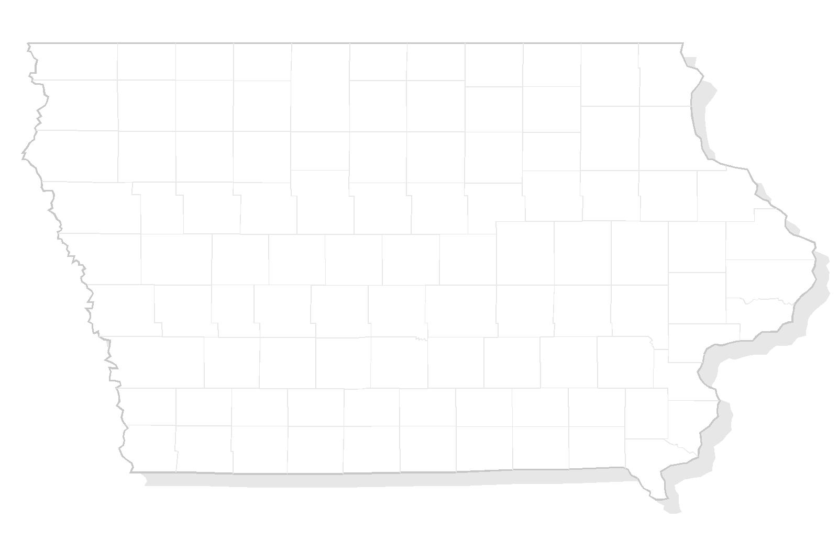

APPENDIX D
DISCLOSURE STATEMENT

THIS PAGE INTENTIONALLY LEFT BLANK

Sample – Disclosure Statement

A disclosure statement, adhering to the form of the statement below, shall be provided to and signed by each potential purchaser of property within the Airport Influence Area as shown on the approved Airport Land Use Drawing. The signed statement will then be affixed by the Seller to the agreement of the sale.

The tract of land situated at
_____________________________________________________________ in __________________________________________________________, consisting of approximately _____________________________________ acres (County and State) which is being conveyed from____________________________ to _______________________ lies within _______ miles of (airport name) may be subjected to varying noise levels, as the same is shown and depicted on the official Zoning Maps.

Certification

The undersigned purchaser(s) of said tract of land certify(ies) that (he) (her) (they) (has) (have) read the above disclosure statement and acknowledge(s) the pre-existence of the airport named above and the noise exposure due to the operation of said airport.

_______________________________________________
(SIGNED)

THIS PAGE INTENTIONALLY LEFT BLANK

