
Iowa Airport Land Use Guidebook

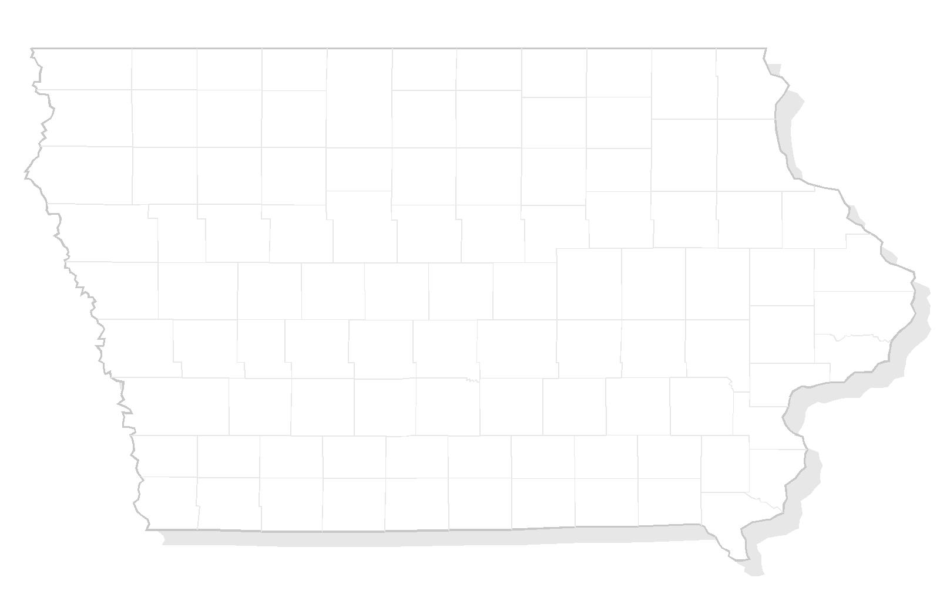

APPENDIX E
NON-SUIT COVENANT

THIS PAGE INTENTIONALLY LEFT BLANK

Sample – Non-Suit Covenant

This indenture made this _____ day of ____________________, 20____, by and between __________________________, hereinafter referred to as Grantor, and ________________ County, a municipal corporation organized and existing under the laws of the State of Iowa, hereinafter referred to as Grantee, witnesseth:

WHEREAS the Grantor is the owner in fee of a certain parcel of land in the County of _________________, State of Iowa; and

WHEREAS the Grantee is the owner and operator of the ____________________________Airport; and

WHEREAS the Grantor proposes to make a use of said land and to develop thereon the following:

_____________________________________________________________

_____________________________________________________________

which use and development require approval by Municipal and County authorities subject to the applicable provisions of law; and

WHEREAS the Grantor, for and on behalf of himself and all successors in interest to any and all of the real property above described, does further hereby covenant and agree with the Grantee, its successors and assigns, that it will not, from and after the effective date hereof, sue, prosecute, molest, or trouble the Grantee, its successors and assigns, in respect to or on account of the flight of any and all aircraft over or near the said parcel of land, or for any effects resulting there from including but not limited to noise, air pollution, or any and all other possible damages to or taking of said property resulting from such flights.

This covenant shall run with the land of the Grantor, as hereinabove described, for the benefit of the Grantee, and its successors and assigns in the ownership, use and operation of the aforesaid airport.

IN WITNESS WHEREOF, the Grantor has hereunto set its hand and seal the day and year first above written.

____________________________________ (SEAL)

____________________________________ (SEAL)

NOTARY ACKNOWLEDGEMENT

STATE OF IOWA

COUNTY OF ________________________

Personally, came before me, this _________ day of _____________, 20____.
_______________________ and _______________________________ of the above named Corporation, to me known to be the person who executed for foregoing instrument and to me known to be such __________________________ and ______________________________ of said Corporation, and acknowledged that they executed the foregoing instrument such officers as the deed of said Corporation, by its authority.

__________________________________________
Notary Public, State of Iowa

My Commission Expires ______________________

