
Iowa Airport Land Use Guidebook

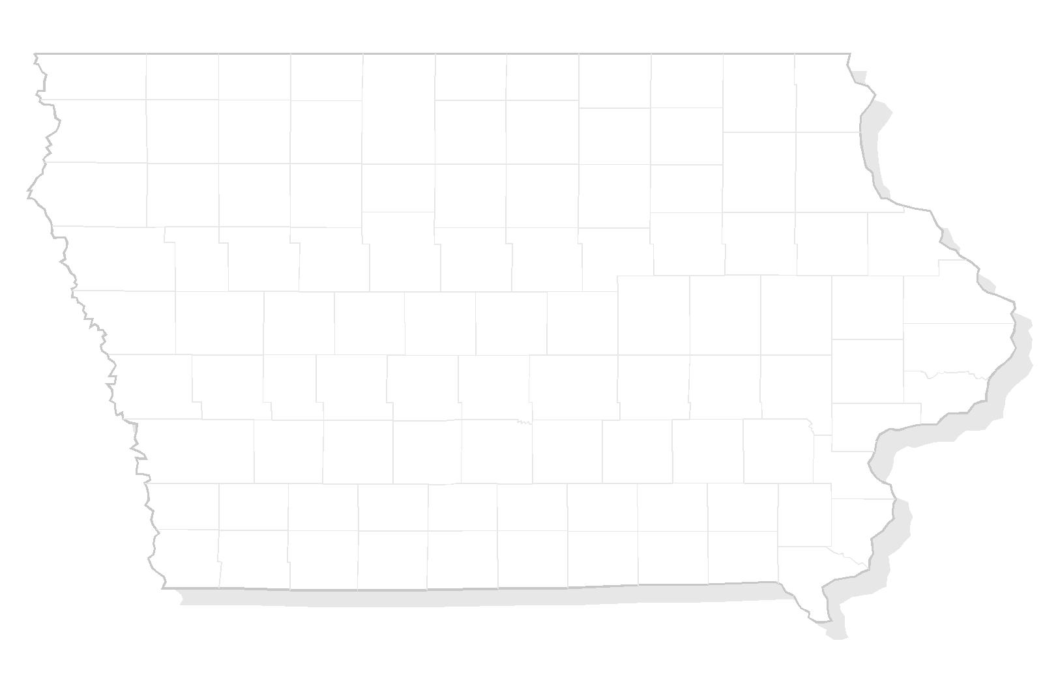

APPENDIX H
HOLD HARMLESS AGREEMENT

THIS PAGE INTENTIONALLY LEFT BLANK

Sample – Hold Harmless Agreement

KNOW ALL MEN BY THESE PRESENTS, that the undersigned, hereinafter referred to as Grantees (whether singular or plural), hereby covenant and agree that they shall not, by reason of their ownership or occupation of the following described real property, protest or bring suit or action against the ________________Airport or the City (County) of ______________ for aviation related noise, property damage or personal injuries resulting from activities at or connected with the _______________Airport when such activities conform to the then existing rules and regulations of said airport and the applicable federal air regulations and no negligence on the part of said airport is involved. The real property of Grantees subject to this covenant and agreement is situated in the County of _________________, State of Iowa, and described as follows:

(Insert legal description and appropriate map)

This covenant and agreement is made and executed by the Grantees in consideration of the City (County) of _________________ granting a conditional use permit for Grantees use and development of the above described real property, which real property is located in the airport approach zone of the ____________________ Airport. The execution of this covenant and agreement by Grantees is required by the City (County) of _____________ as a prerequisite to the granting of the above said conditional use permit to Grantees. This agreement is executed for the protection and benefit of the ________________ Airport and the City (County) of _______________________ interest in said airport and to prevent development in adjacent lands to said airport which will interfere with the continued operation existent and development of said airport. This covenant and agreement is intended to be binding upon the Grantees, their heirs, assigns, and successors and inure to the benefit of the City (County) of _______________ and the Airport, their successors and assigns.
DATED this ___________ day of _____________________, 20____.

STATE OF IOWA ) GRANTEES:
) ) ss.____________________
City/County of ) ______________________

THIS PAGE INTENTIONALLY LEFT BLANK

