**Subject:** Primary County, Phase Number - D5 Submittal

**D5 - ROW Submittal:**

Primary County:

Project Code:

Phase Number:

Phase Location:

Work Code:

  Project Directory Number:

**D5 Submittal Folder:**  [Place](http://www.iowadot.gov/design/mkretlo/Local%20Settings/mkretlo/Projects/9106503004/Design/D3Submittal/D3sub%20Warren.PDF)_link_here

**Project Documentation File**:  [Place](http://www.iowadot.gov/design/mkretlo/Local%20Settings/mkretlo/Projects/9106503004/Design/D3Submittal/D3sub%20Warren.PDF)_link_here

**KMZ File**:  [Place](http://www.iowadot.gov/design/mkretlo/Local%20Settings/mkretlo/Projects/9106503004/Design/D3Submittal/D3sub%20Warren.PDF)_link_here

This waterway is (or is not) on a state water trail or paddling route.

**D5 Checklist**

Traffic will be maintained via:

No change  Staging  Runaround  Detour  Other

Project Packaging

Yes No

☐ ☐ A packaging meeting will need to be scheduled by the Project Manager for this project.

*Add information to address any incomplete items below:*

**Yes N/A No**

Completed x-section .pdf available.

Culverts and structures complete

S2 complete (stability berms complete)

Overhead signs and signals preliminary location identified.

Structure TS+L for all 4’ and larger, pipes or culverts.

Splash basins for pipe culverts sized and located.

Intercepting ditch locations identified.

Access Rights to be acquired.

Entrance (PDA) locations match access control letter.

Entrance profile(s) on the plans and x-sections

Entrances labeled as Proposed, Closed or U.A.C.

Final ditching complete

Special Mitigation ROW requirements identified.

Railroad within 50’ of project

Temporary easements identified.

Unique features (ex. Ponding easements, snow borrows, etc.)

Side road construction or relocations

If you have any questions or comments, feel free to email me.

**To:**

Hofer, Brad;

**Cc:**

Kennerly, Michael; Nicholson, Kent; Nelson, James S; Nop, Michael; Musgrove, Wes; Meyer, Ronald; Ellis, Jimmy; Majors, Shawn; Poole, Chris; Stokes, Danny; Swenson, Mark A; Johnson, Katherine; Wright, Eric; Anderson, Stuart; Laaser-Webb, Jan; Bradley, Bryan; Sorenson, Willy; Azeltine, Brad; Cuva, Nicole; Brink, Kenneth; Poole, Angela; Dell, Mark; Smith, Brian; Van Dyke, Mark; Ta, Dung; Pohlen, Nathan; Heeren, Douglas; Cagle, Gregory; Blue, Dana; Cook, Sarah; Armstrong, Leilah

**District 1:**

Smyth, Allison; Vortherms, Jeremey; Passick, Sean; Adey, Ben; Matulac, Donna;

*Location and Environment (Cultural, T&E, Water, PI):*

Becker, Janee; Garton, Jill; Brewer, Valerie;

Asberry, Claire; Boone, Greene

Carlson, Michael; Polk, Story, Webster

Beavers, Brandy; Jasper, Poweshiek

Sloppy, Mark; Marshall, Tama

Walls, Brandon; Grundy, Hamilton, Hardin

*NEPA contacts:*

Newell, DeeAnn; Walter, Blake;

**District 2:**

Humpal, Nickolas; Kelly, Mary; Eilders, Miranda; Erickson, Daryl;

Smith, Kevin; *Bridge Projects*

*Location and Environment (Cultural, T&E, Water, PI):*

Bacon, Jeff; Struecker, Brock; Walls, Brandon; Brewer, Valerie;

*NEPA contacts:*

Newell, DeeAnn; Leanos, Pedro;

**District 3:**

Felix, Jessica; Tymkowicz, Shane; Thayer, Michael; Huju, Todd; Pryor, Dylan

Sadler, Mark; *(Maintenance and 3R Projects)*

*Location and Environment (Cultural, T&E, Water, PI):*

Becker, Janee; Struecker, Brock; Walls, Brandon; Brewer, Valerie; Sturtz, Samuel

*NEPA contacts:*

Newell, DeeAnn; Schwienebart, Chris;

**District 4:**

Schram, Scott; Mayberry, Wes; Epperson, Nathaniel; Fox, Bill;

Lechnowsky, Orest; Kohl, Jason; Harrison, Pottawattamie, Mills, Fremont, Page, Montgomery, & Shelby

Malone, Travis; Mocha, Nicholas; Audubon, Cass, Adams, Taylor, Guthrie, Adair, Union, Ringgold, Dallas, & Madison

Cihacek, Joseph; Harrison, Shelby, Pottawattamie, Mills, Montgomery, Fremont, & Page

Todd, Frank; Audubon, Guthrie, Dallas, Cass, Adair, Madison, Adams, Union, Taylor, & Ringgold

*Location and Environment (Cultural, T&E, Water, PI):*

Woodcock, Jacob; Garton, Jill; Asberry, Claire; Rees, Jon;

*NEPA contacts:*

Newell, DeeAnn; Schwake, Christine;

**District 5:**

Younie, Bob; McElmeel, Steven; Claeys, Mark; Clancy, Bonnie;

*Location and Environment (Cultural, T&E, Water, PI):*

Woodcock, Jacob; Garton, Jill; Beavers, Brandy; Rees, Jon;

*NEPA contacts:*

Newell, DeeAnn; Leanos, Pedro;

**District 6:**

Schnoebelen, Jim; Tibodeau, Jesse; Morrell, George;

*Location and Environment (Cultural, T&E, Water, PI):*

Bacon, Jeff; Struecker, Brock; Sloppy, Mark; Rees, Jon;

*NEPA contacts:*

Newell, DeeAnn; Schwake, Christine;

**Railroad impacts:**

Woods, Amanda;

**Projects on new alignment or adding lanes to create a multilane facility:**

Mauer, Paul; Clement, Jodi; Bernhard, Charles;

**For Interstate Projects:**

[Program.Delivery-IA@dot.gov](mailto:Program.Delivery-IA@dot.gov)

**District TSMO Engineers:**

Swisher, Andy; District 1, District 2 (except Blackhawk Co.), and I-35 in District 5

Yates, Austin; District 3 and District 4

Abuissa, Newman; District 6, District 5 (except I-35), and Blackhawk Co. (District 2)

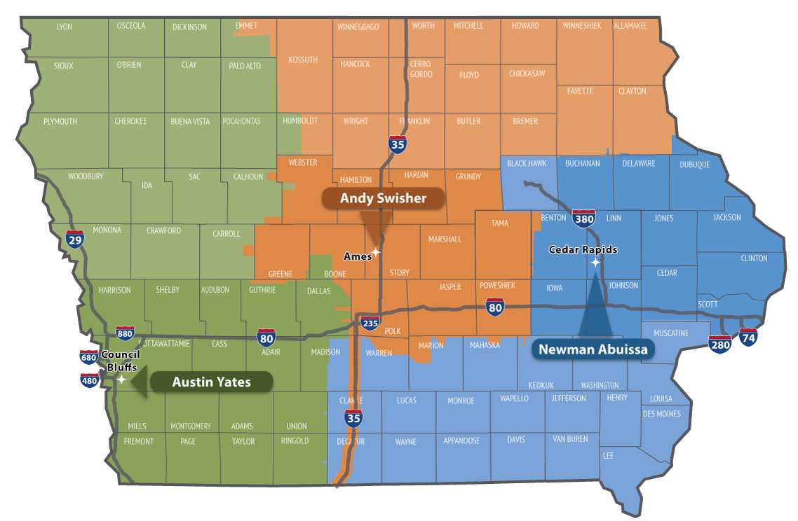

**Contact revision request:**

Email [DOT-Shell-Support](mailto:DOT-Shell-Support@iowadot.us?subject=D5%20Shell%20Letter%20Contact%20revision%20request%20)

Subject: D5 Shell Letter Contact revision request

Copy and Paste into body of email

Please change the Shell Letter Contact *[Contacts name and email]*.

They were in this position *[Title ; position ; District ; Bureau].*

They reported to *[Contacts name and email].*

*[Contacts name and email]* is the New *[Title ; position ; District ; Bureau]*.

This change needs to be done on *[ALL Shell Letters; Indicate Shell Letter(s) if different then email subject].*

Thank you

**Revision request:**

Email [DOT-Shell-Support](mailto:DOT-Shell-Support@iowadot.us?subject=D5%20Shell%20Letter%20revision%20request%20)

Subject: D5 Shell Letter revision request

Copy and Paste into body of email

Please find the attached Markup with the requested change. [Screen image of change, or marked up document]

This change needs to be done on *[ALL Shell Letters; Indicate Shell Letter(s) if different then email subject].*

Thank you