Agency Coordination List
US EPA – National Environmental Policy Act Team – Region VII
US DOI – US Fish and Wildlife Service – Rock Island*
US DOI – US Fish and Wildlife Service – Grand Island*
US DOI – National Park Service (when NPS lands involved)
US DOI – Regional Office in Denver (when Section 4(f) properties may be involved)
US Army Corps of Engineers – Rock Island District * (cooperating agency)
US Army Corps of Engineers – Omaha District * (cooperating agency)
US Army Corps of Engineers – NE Iowa * (cooperating agency)
US Coast Guard (when on navigable streams) (cooperating agency)
NRCS – State conservationist
US Department of Housing and Urban Development (as necessary in urban areas)
Federal Emergency Management Agency (when floodplains are involved)
Federal Aviation Agency (when near airports)
Federal Transit Administration (as necessary)
Federal Railroad Administration (when RR involved)
State Historical Society of Iowa (CC as FYI only)
Iowa DNR – Environmental Services Division
Iowa DNR – Conservation and Recreation Division
Iowa DNR – Land and Water Conservation Fund Program [to verify Section 6(f)]**
Other local agencies as necessary:
County Conservation Board
County Board of Supervisors
Historical Societies
City Planning Department
County Planning Department
County Engineer
Public Works Director (or City Engineer)
Mayor (City Council or City Manager)
Local IDNR (see map)
Local NRCS Conservationist (relates to USDA Form 1006)
Iowa Soil and Water Conservation Districts (Ag land present)
Iowa Department of Agriculture and Land Stewardship (Ag land present)
Chamber of Commerce

Parks and Recreation Department

DOT/FHWA

Deanne Popp– Bureau of Right of Way (for utility notification)

Cultural Resource Section (for Tribal notification)

NEPA Document Manager – copy of EC packet and distribution list (cc)

FHWA NEPA – copy of EC packet and distribution list (cc as FYI only)

* Depending on location of project. In some cases, such as where Nebraska DOR is the lead, coordination may be necessary with Nebraska districts.
**These agencies can be notified as necessary
Ask USACE and USCG to be cooperating agencies if EIS is prepared; This is done with a scoping packet or letter. See Tab 1 of Iowa FHWA Division Manual.
Additional Address Information

Local DNR Wildlife Biologist – you may find the appropriate biologist name and address by calling the DNR District Supervisor.
SE – Don Pfeiffer 319/ 694-2430
SW – Bob Moore 712/ 769-2587
NW – Neil Heiser 712/ 336-1840

NE – Art Roseland 319/ 927-3276

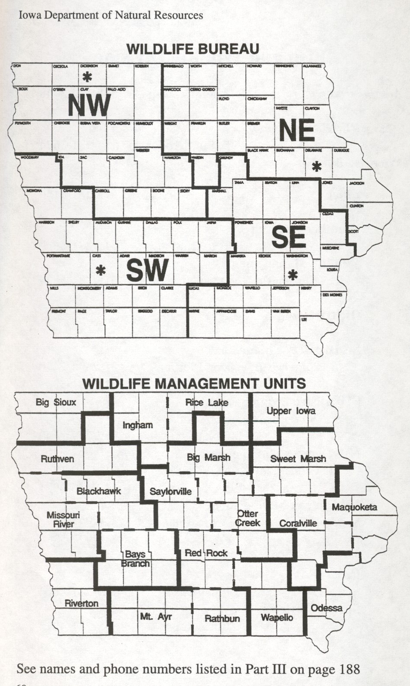

County Conservation Board – you may find the appropriate CCB address at the following web site: http://george.ecity.net/iaccb/ccbs.html

List of Possible Cooperating Agencies
Agencies asked due to jurisdiction:
US EPA – National Environmental Policy Act Team – Region VII
US DOI – US Fish and Wildlife Service – Rock Island* (T&E species or refuge encroachment)
US DOI – US Fish and Wildlife Service – Grand Island* (T&E species or refuge encroachment)
US DOI – National Park Service (NPS lands or Section 6(f) funds involved)
US Army Corps of Engineers – Rock Island District * (when waters of the US, including wetlands, are involved)
US Army Corps of Engineers – Omaha District * (when waters of the US, including wetlands, are involved)
US Army Corps of Engineers – NE Iowa * (when waters of the US, including wetlands, are involved)
US Coast Guard (when on navigable streams)
Other federal agencies may be asked if the project has additional federal interests from those listed above (note it would be rare to ask these agencies). Examples include:
FEMA
Federal Aviation Agency
Federal Transit Administration
HUD
Advisory Council on Historic Preservation
Department of Defense

* Depending on location of project

- Ask for cooperating agencies if EIS is prepared; This is done with a scoping packet or early coordination letter. See Tab 1 of Iowa FHWA Division Manual and the OLE Manual for more information.

- Agencies should be asked that have jurisdiction in the project area. Listed above are the agencies that are most often asked for DOT projects. Other agencies may be asked if they have special expertise, including: regional planning agencies, Iowa DNR, County Conservation Boards, Historical Societies, etc. However, it is preferable to ask these agencies to be contributing agencies. See Tab 1 or the Iowa FHWA Division Manual and the OLE Manual for more information.

- Send FHWA a copy of the IC packet or Scoping letter where these requests occur as well as responses to the requests.

- If there is a request to send the IC to governing officials (e.g. governor, state/federal legislature), notify supervisor/office director.

